A

Major Project

On

Virtual Trial Room

(Submitted in partial fulfilment of the requirements for the award of Degree) BACHELOR’S OF TECHNOLOGY

in

COMPUTER SCIENCE AND ENGINEERING

By

**Narla Krishna Lekha (187R1A05G9)**

**Neeraj Kumar Karnati (187R1A05H0)**

**Siripuram Akhila (187R1A05H6)**

Under the Guidance of

1. **Uday Kiran**

(Assistant Professor)



### DEPARTMENT OF COMPUTER SCIENCE AND ENGINEERING

**CMR TECHNICAL CAMPUS**

**UGC AUTONOMOUS**

(Accredited by NAAC, NBA, Permanently Affiliated to JNTUH, Approved by AICTE, New Delhi) Recognized Under Section 2(f) & 12(B) of the UGC Act.1956,

Kandlakoya (V), Medchal Road, Hyderabad-501401.

**2018-22**

### DEPARTMENT OF COMPUTER SCIENCE AND ENGINEERING



**CERTIFICATE**

This is to certify that the project entitled “**Virtual Trial Room**” being submitted by **Narla Krishna Lekha (187R1A05G9), Neeraj Kumar Karnati (187R1A05H0)** & **Siripuram Akhila (187R1A05H6)** in partial fulfillment of the requirements for the award of the degree of B. Tech in Computer Science and Engineering to the Jawaharlal Nehru Technological University Hyderabad, is a record of bonafide work carried out by him/her under our guidance and supervision during the year 2021-22.

The results embodied in this thesis have not been submitted to any other University or Institute for the award of any degree or diploma.

**Mr. A. Uday Kiran Dr. A. Raji Reddy**

**Assistant Professor DIRECTOR INTERNAL GUIDE**

**Dr. K. Srujan Raju EXTERNAL EXAMINER**

**HOD**

**Submitted for viva voice Examination held on**

**ACKNOWLEDGEMENT**

Apart from the efforts of us, the success of any project depends largely on the encouragement and guidelines of many others. We take this opportunity to express our gratitude to the people who have been instrumental in the successful completion of this project.

We take this opportunity to express my profound gratitude and deep regard to my guide Mr. **A. Uday Kiran,** Assistant Professor for his exemplary guidance, monitoring and constant encouragement throughout the project work. The Blessing, help and guidance given by him shall carry us a long way in the journey of life on which we are about to embark. We also take this opportunity to express a deep sense of gratitude to the Project Review Committee (PRC) **Mr. J. Narasimha Rao, Dr. T. S. Mastan Rao, Mr. A. Uday Kiran, Mr. A. Kiran Kumar, Mrs. G. Latha** for their cordial support, valuable information and guidance, which helped us in completing this task through various stages.

We are also thankful to **Dr. K. Srujan Raju,** Head, Department of Computer Science and Engineering for providing encouragement and support for completing this project successfully.

We are obliged to **Dr. A. Raji Reddy,** Director for being cooperative throughout the course of this project. We also express our sincere gratitude to Sri. **Ch. Gopal Reddy,** Chairman for providing excellent infrastructure and a nice atmosphere throughout the course of this project.

The guidance and support received from all the members of **CMR Technical Campus** who contributed to the completion of the project. We are grateful for their constant support and help.

Finally, we would like to take this opportunity to thank our family for their constant encouragement, without which this assignment would not be completed. We sincerely acknowledge and thank all those who gave support directly and indirectly in the completion of this project.

**Narla Krishna Lekha (187R1A05G9)**

**Neeraj Kumar Karnati (187R1A05H0)**

**Siripuram Akhila (187R1A05H6)**

### ABSTRACT

By utilizing depth cameras like the Microsoft Kinect, it becomes possible to track the movements of a body, extract body measurements and furthermore create a virtual mirror with the corresponding video stream. The video image can be merged with a piece of clothing frame by frame. The clothes are adapted to the body of the user in front of the Kinect during runtime. Furthermore, trying on clothes in front of different backgrounds and surroundings (e.g., at night) shall be possible. Artificial environment created with software. Online equivalent of an in-store changing room. Enables shoppers to try on clothes virtually. First application known as WSS developed by Zugara. WSS is known as a fitting room or magic mirror.

## 

## LIST OF FIGURES

|  |  |  |
| --- | --- | --- |
| **FIGURE NO** | **FIGURE NAME** | **PAGE NO** |
| Figure 3.1 | Project Architecture | 6 |
| Figure 3.2 | Face Detection Points | 7 |
| Figure 3.3 | Body Detection Points | 7 |
| Figure 3.4 | Use case diagram for User | 8 |
| Figure 3.5 | Class diagram | 9 |
| Figure 3.6 | Sequence diagram for User | 10 |
| Figure 3.7 | Sequence diagram for Detection | 10 |
| Figure 3.8 | Activity diagram | 11 |

## LIST OF SCREENSHOTS

|  |  |  |
| --- | --- | --- |
| **FIGURE NO** | **SCREENSHOT NAME** | **PAGE NO** |
| Figure 5.1 | USER INTERFACE 1 (Basic Design) | 22 |
| Figure 5.2 | Browse Necklaces (User Interface) | 22 |
| Figure 5.3 | Browse Googles (User Interface) | 23 |
| Figure 5.4 | Browse Frocks (User Interface) | 23 |
| Figure 5.5 | Output 1 (Detection and Masking) | 24 |
| Figure 5.6 | Output 2 (Detection and masking) | 24 |
|  |  |  |
|  |  |  |

## LIST OF CONTENTS

|  |  |  |  |  |
| --- | --- | --- | --- | --- |
| **ABSTRACT** | |  |  | i |
| **LIST OF FIGURES** | | |  | ii |
| **LIST OF SCREENSHOTS** | | | | iii |
| **LIST OF CONTENTS** | | | | iv |
| **1.** | **INTRODUCTION** | | | 1 |
|  | 1.1 | PROJECT INTRODUCTION | | 1 |
|  | 1.2 | PROJECT PURPOSE | | 1 |
|  | 1.3 | PROJECT FEATURES | | 1 |
| **2.** | **SYSTEM ANALYSIS** | | | 2 |
|  | 2.1 | PROBLEM DEFINITION | | 2 |
|  | 2.2 | EXISTING SYSTEM | | 2 |
|  |  | 2.2.1 | LIMITATIONS OF THE EXISTING SYSTEM | 2 |
|  | 2.3 | PROPOSED SYSTEM | | 3 |
|  |  | 2.3.1 | ADVANTAGES OF PROPOSED SYSTEM | 3 |
|  | 2.4 | FEASIBILITY STUDY | | 3 |
|  |  | 2.4.1 | ECONOMIC FEASIBILITY | 4 |
|  |  | 2.4.2 | TECHNICAL FEASIBILITY | 4 |
|  |  | 2.4.3 | BEHAVIORAL FEASIBILITY | 4 |
|  | 2.5 | HARDWARE & SOFTWARE REQUIREMENTS | | 5 |
|  |  | 2.5.1 | HARDWARE REQUIREMENTS | 5 |
|  |  | 2.5.2 | SOFTWARE REQUIREMENTS | 5 |
| **3.** | **ARCHITECTURE** | | | 6 |
|  | 3.1 | PROJECT ARCHITECTURE | | 6 |
|  | 3.2 | MODULES DESCRIPTION | | 6 |
|  |  | 3.2.1 USER | | 7 |
|  |  | 3.2.2 DETECTION | | 7 |
|  |  | 3.2.3 MASKING | | 8 |
|  |  | 3.2.4 OUTPUT | | 8 |
|  | 3.3 | USE CASE DIAGRAM | | 8 |
|  | 3.4 | CLASS DIAGRAM | | 9 |
|  | 3.5 | SEQUENCE DIAGRAM | | 10 |
|  | 3.6 | ACTIVITY DIAGRAM | | 11 |

## LIST OF CONTENTS

|  |  |  |  |
| --- | --- | --- | --- |
| **4.** | **IMPLEMENTATION** | | 12 |
|  | 4.1 | SAMPLE CODE | 12 |
| **5.** | **SCREENSHOTS** | | 22 |
| **6.** | **TESTING** | | 25 |
|  | 6.1 | INTRODUCTION TO TESTING | 25 |
|  | 6.2 | TYPES OF TESTING | 25 |
|  |  | 6.2.1 UNIT TESTING | 25 |
|  |  | 6.2.2 INTEGRATION TESTING | 25 |
|  |  | 6.2.3 FUNCTIONAL TESTING | 26 |
| **7.** | **CONCLUSION & FUTURE SCOPE** | | 27 |
|  | 7.1 | PROJECT CONCLUSION | 27 |
|  | 7.2 | FUTURE SCOPE | 27 |
| **8.** | **REFERENCES** | | 28 |
|  | 8.1 | REFERENCES | 28 |
|  | 8.2 | WEBSITES | 28 |
|  |  |  |  |

**1. INTRODUCTION**

1. INTRODUCTION

### 1.1 PROJECT INTRODUCTION

This project is titled as “Virtual Dressing Room”. This web application provides a facility to try the garment virtually. This project detects the body of the user and assigns the points over the body. The images of the garments are masked on the user using these points and the user is then given with the masked output.

### 1.2 PROJECT PURPOSE

The purpose of the project is to reduce the tedious process of going to the physical stores and trying the garment. This project helps to check whether the garments are suitable for him or not. This way we can reduce the burden of the user. This project tries to save a lot of time of the user and helps him choose the right garment for him.

### 1.3 PROJECT FEATURES

The main feature of this project is that the user can try the garments virtually. The user can select his favorite garment and try it and make sure the product is suitable for him. The garments provided online cannot be verified whether it is suitable for him or not. This project facilitates the user to check the garments and try them on at their own home virtually.

# 2.SYSTEM ANALYSIS

# 

2. SYSTEM ANALYSIS

### SYSTEM ANALYSIS

System Analysis is the important phase in the system development process. The System is studied to the minute details and analysed. The system analyst plays an important role of an interrogator and dwells deep into the working of the present system. In analysis, a detailed study of these operations performed by the system and their relationships within and outside the system is done. A key question considered here is, “what must be done to solve the problem?” The system is viewed as a whole and the inputs to the system are identified. Once analysis is completed the analyst has a firm understanding of what is to be done.

### 2.1 PROBLEM DEFINITION

A detailed study of the process must be made by various techniques like Image processing, feature recognition etc. The data collected by these sources must be scrutinised to arrive at a conclusion. The conclusion is an understanding of how the system functions. This system is called the existing system. Now the existing system is subjected to close study and problem areas are identified. The designer now functions as a problem solver and tries to sort out the difficulties that the enterprise faces. The solutions are given as proposals. The proposal is then weighed with the existing system analytically and the best one is selected. The proposal is presented to the user for an endorsement by the user. The proposal is reviewed on user request and suitable changes are made. This is a loop that ends as soon as the user is satisfied with the proposal.

### 2.2 EXISTING SYSTEM

Currently lenskart uses augmented reality for the virtual trail of the spectacles or goggles. Other goods require the physical presence to try them and this existing system requires a lot of effort to reach the concerned place and try the goods. This requires a lot of time for the customers to try the goods.

#### 2.2.1 LIMITATIONS OF EXISTING SYSTEM

* Going to the malls and trying the goods is a tedious process.
* It takes a lot of time to try the goods.

To avoid all these limitations and make the working more accurate the system needs to be implemented efficiently.

### 2.3 PROPOSED SYSTEM

The aim of the proposed system is to develop a system of improved facilities. The proposed system can overcome all the limitations of the existing system. The proposed system is to create a virtual dress trial room where people can try the online goods such as clothes, googles, and other accessories. These days online shopping has grown tremendously and people or customers will not be able to try them. Our proposed system eliminates that problem and customers can try the online goods by sitting in front of the system.

### 2.3.1 ADVANTAGES OF THE PROPOSED SYSTEM

The system is very simple in design and to implement. The system requires very low system resources and the system will work in almost all configurations. It has got following features.

* The proposed system helps the customers by saving a lot of time in trying the goods.
* It reduces the effort of trying the goods in confined places.

### 2.4 FEASIBILITY STUDY

The feasibility of the project is analysed in this phase and a business proposal is put forth with a very general plan for the project and some cost estimates. During system analysis the feasibility study of the proposed system is to be carried out. This is to ensure that the proposed system is not a burden to the company. Three key considerations involved in the feasibility analysis are

* Economic Feasibility
* Technical Feasibility
* Social Feasibility

### 2.4.1 ECONOMIC FEASIBILITY

The developing system must be justified by cost and benefit. Criteria to ensure that effort is concentrated on a project, which will give best, return at the earliest. One of the factors, which affect the development of a new system, is the cost it would require.

The following are some of the important financial questions asked during preliminary investigation:

* The costs conduct a full system investigation.
* The cost of the hardware and software.
* The benefits in the form of reduced costs or fewer costly errors.

Since the system is developed as part of project work, there is no manual cost to spend for the proposed system. Also, all the resources are already available, it gives an indication that the system is economically possible for development.

### 2.4.2 TECHNICAL FEASIBILITY

This study is carried out to check the technical feasibility, that is, the technical requirements of the system. Any system developed must not have a high demand on the available technical resources. The developed system must have a modest requirement, as only minimal or null changes are required for implementing this system.

### 2.4.3 BEHAVIOURAL FEASIBILITY

This includes the following questions:

* Is there sufficient support for the users?
* Will the proposed system cause harm?

The project would be beneficial because it satisfies the objectives when developed and installed. All behavioral aspects are considered carefully and conclude that the project is behaviorally feasible

### 2.5 HARDWARE & SOFTWARE REQUIREMENTS

**2.5.1 HARDWARE REQUIREMENTS:**

Hardware interfaces specify the logical characteristics of each interface between the software product and the hardware components of the system. The Following are some hardware requirements.

* Processor : Intel i5, Ryzen 7
* Hard disk : 20 GB
* RAM : 8GB */* 16GB */* 32GB
* Input Devices : Keyboard, Mouse, SmartPhone (Android,IOS)

### 2.5.2 SOFTWARE REQUIREMENTS:

Software Requirements specifies the logical characteristics of each interface and software components of the system. The following are some software requirements,

* Operating System : Windows 10, Linux
* Programming language : Python
* Tools and frameworks : Opencv, vs code, mediapipe
* Backend : flask

**3.ARCHITECTURE**

## ARCHITECTURE

### 3.1 PROJECT ARCHITECTURE

This project architecture shows the procedure followed for Virtual Dressing Room. The user either use a web cam or uploads the photo of his choice. Using the photo, it detects the full body and capture the points. The image is masked and then it is sent to the webpage. The output is shown on the output screen of user.

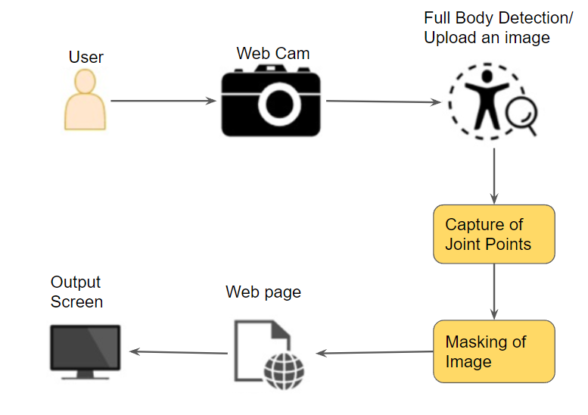

Figure 3.1: Project Architecture

### 3.2 MODULES DESCRIPTION

**Modules**

* user
* Detection
* Masking
* Output

**3.2.1 User:**

Through the interface the user can view the garment and choose the garments of their choice. They can add to the cart their favourite items into the cart.  
  
**3.2.2 Detection:**

The detection module detects the body joints using the framework called mediapipe. This detection of body joints helps in masking the video feed given to the system.

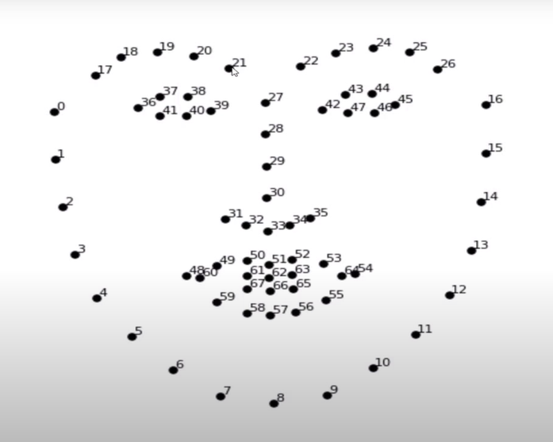

Figure 3.2: Face Detection Points

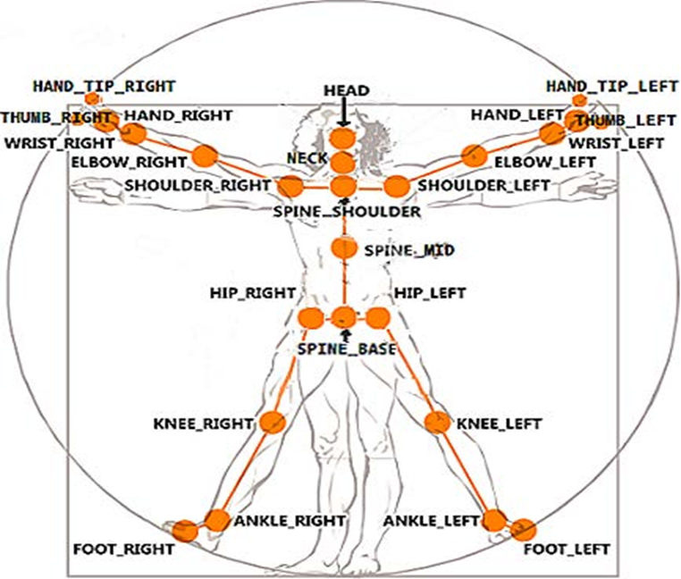

Figure 3.3: Body Detection Points

**3.2.3 Masking:**

In this masking module, the garments that the user chose are masked on the user using the body joints detected in the detection module.

**3.2.4 Output:**

Output module provides the user with the masked video feed. The masked video feed is a real time. The masked video feed takes the reference of the user’s eye feed.

### 3.3 USE CASE DIAGRAM

In the use case diagram, we have a user as an actor who can browse Garment catalogue, view Garments, try garments and save the snapshot. In try garments on module, it involves capturing body skeleton joints and masking the garment on the user’s captured image or uploaded image. It is then sent to the user as a snapshot.

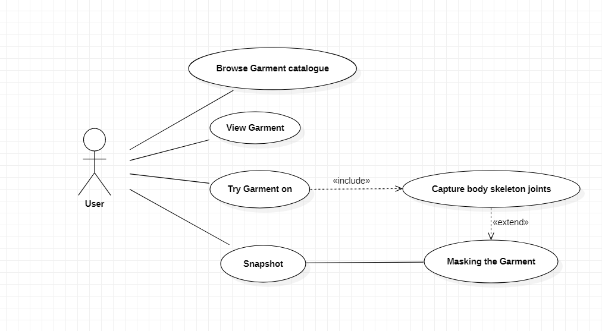

Figure 3.4: Use Case Diagram for User

### 3.4 CLASS DIAGRAM

Class Diagram is a collection of classes and objects. This project consists of a user class with objects such as browse the catalogue, try garments and add to cart. The detection class performs the capturing of body joints with camera feed or input image given to it as input. The masking class performs masking of the garments where the selected garment is placed or masked according to the captured body joints. The output class helps the user to save the snapshots using savesnap operation.

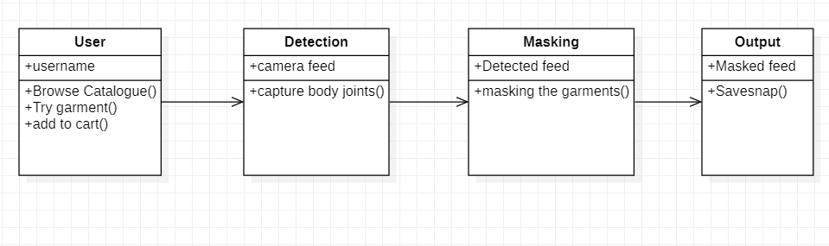

Figure 3.5: Class Diagram

### 3.5 SEQUENCE DIAGRAM

**User Sequence Diagram:**

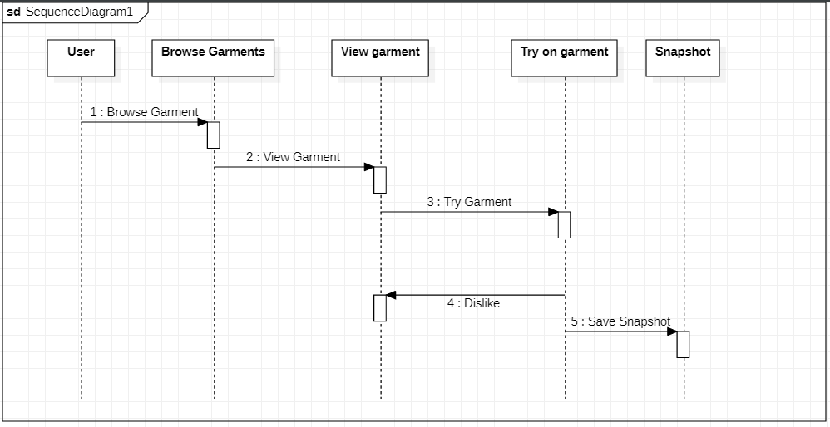 The user object interacts with the browse garment object which interacts with the view garment object which invokes the try on garment object which displaces the user with a masked image. If the user likes it, he interacts with the save snapshot else he will continue browsing the garments.

Figure 3.6: Sequence Diagram of User

**Detection Sequence Diagram:**

The detection module will initialise the detection process if the appropriate distance is followed by the user. The detection module interacts with capture joints object which upon successful capture interacts with masking which masks the image on the user. The masked image is given to the user as a snapshot.

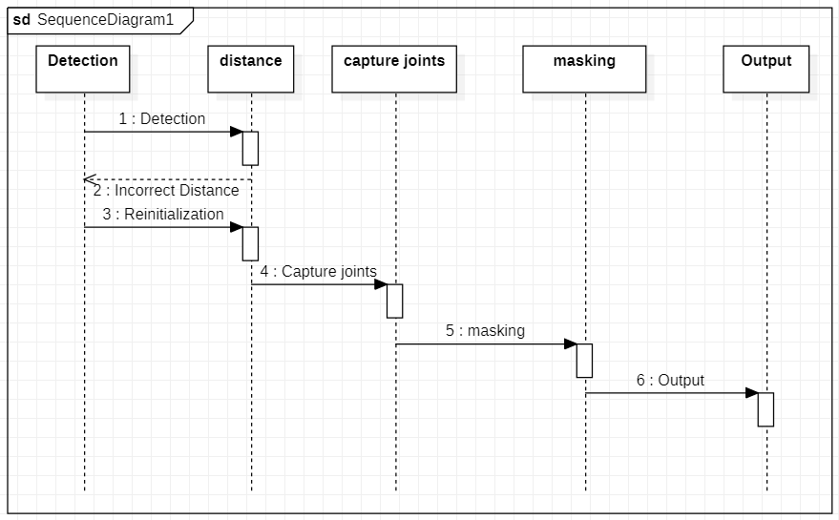

Figure 3.7: Sequence Diagram of Detection.

### 3.6 ACTIVITY DIAGRAM

It describes the flow of activity states. The different activity states are start, browse garments, view garments, try on garments, initialise capture, if correct distance is maintained capture joints, else reinitialize the capture, output the snapshots.

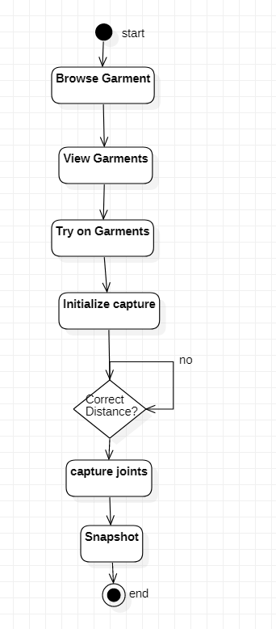

Figure 3.8: Activity Diagram.

# 4.IMPLEMENTATION

# IMPLEMENTATION

**4.1 SAMPLE CODE**

from tkinter import *

from PIL import Image

from PIL import ImageTk

import sys

import cv2, threading, os, time

from threading import Thread

from os import listdir

from os.path import isfile, join

import dlib

from imutils import face_utils, rotate_bound

import math

def put_sprite(num):

global SPRITES, BTNS

SPRITES[num] = (1 - SPRITES[num])

# if SPRITES[num]:

# BTNS[num].config(relief=SUNKEN)

# else:

# BTNS[num].config(relief=RAISED)

def draw_sprite(frame, sprite, x_offset, y_offset):

print("sprite>>>>>>>", sprite.shape ,"type=", type(sprite.shape))

(h,w) = (sprite.shape[0], sprite.shape[1])

(imgH,imgW) = (frame.shape[0], frame.shape[1])

if y_offset+h >= imgH:

sprite = sprite[0:imgH-y_offset,:,:]

if x_offset+w >= imgW:

sprite = sprite[:,0:imgW-x_offset,:]

if x_offset < 0:

sprite = sprite[:,abs(x_offset)::,:]

w = sprite.shape[1]

x_offset = 0

for c in range(3):

try:

frame[y_offset:y_offset+h, x_offset:x_offset+w, c] = \

sprite[:,:,c] * (sprite[:,:,3]/255.0) + frame[y_offset:y_offset+h, x_offset:x_offset+w, c] * (1.0 - sprite[:,:,3]/255.0)

except Exception as e:

print(e)

pass

return frame

def adjust_sprite2head(sprite, head_width, head_ypos, ontop = True):

(h_sprite,w_sprite) = (sprite.shape[0], sprite.shape[1])

factor = 1.0*head_width/w_sprite

sprite = cv2.resize(sprite, (0,0), fx=factor, fy=factor)

(h_sprite,w_sprite) = (sprite.shape[0], sprite.shape[1])

y_orig = head_ypos-h_sprite if ontop else head_ypos

if (y_orig < 0):

sprite = sprite[abs(y_orig)::,:,:]

y_orig = 0

return (sprite, y_orig)

def apply_sprite(image, path2sprite,w,x,y, angle, ontop = True):

sprite = cv2.imread(path2sprite,-1)

sprite = rotate_bound(sprite, angle)

(sprite, y_final) = adjust_sprite2head(sprite, w, y, ontop)

image = draw_sprite(image,sprite,x, y_final)

def calculate_inclination(point1, point2):

x1,x2,y1,y2 = point1[0], point2[0], point1[1], point2[1]

incl = 180/math.pi*math.atan((float(y2-y1))/(x2-x1))

return incl

def calculate_boundbox(list_coordinates):

x = min(list_coordinates[:,0])

y = min(list_coordinates[:,1])

w = max(list_coordinates[:,0]) - x

h = max(list_coordinates[:,1]) - y

return (x,y,w,h)

def detectUpperBody(image):

cascadePath = 'data/haarcascade_upperbody.xml'

result = image.copy()

imageGray = cv2.cvtColor(image, cv2.COLOR_BGR2GRAY)

cascade = cv2.CascadeClassifier(cascadePath)

Rect = cascade.detectMultiScale(imageGray, scaleFactor=1.1, minNeighbors=1, minSize=(1,1))

if len(Rect) <= 0:

return False

else:

return Rect

def get_face_boundbox(points, face_part):

if face_part == 1:

(x,y,w,h) = calculate_boundbox(points[17:22])

elif face_part == 2:

(x,y,w,h) = calculate_boundbox(points[22:27])

elif face_part == 3:

(x,y,w,h) = calculate_boundbox(points[36:42])

elif face_part == 4:

(x,y,w,h) = calculate_boundbox(points[42:48])

elif face_part == 5:

(x,y,w,h) = calculate_boundbox(points[29:36])

elif face_part == 6:

(x,y,w,h) = calculate_boundbox(points[0:17])

elif face_part == 7:

# (x,y,w,h) = calculate_boundbox(points[48:68]) #mouth

(x,y,w,h) = calculate_boundbox(points[1:5])

elif face_part == 8:

(x,y,w,h) = calculate_boundbox(points[12:16])

return (x,y,w,h)

image_path = ''

def add_sprite(img):

global image_path

image_path = img

print("rsplit of imgpath>>>>>>>",img.rsplit('/',1))

print(">>>>>>>>>>>",int(img.rsplit('/',1)[0][-1]))

put_sprite(int(img.rsplit('/',1)[0][-1])) #here it will return the integer value from 1 to 6, which will denotes that which catagory is the apparel belongs to i.e either frock or tops or etc.

#Principal Loop where openCV (magic) ocurs

# Face detection starts from here

def cvloop(run_event):

global panelA

global SPRITES

global image_path

i = 0

video_capture = cv2.VideoCapture(0) #read from webcam

(x,y,w,h) = (0,0,10,10) #whatever initial values

#Filters path

detector = dlib.get_frontal_face_detector()

model = "data/shape_predictor_68_face_landmarks.dat"

predictor = dlib.shape_predictor(model) # link to model: http://dlib.net/files/shape_predictor_68_face_landmarks.dat.bz2

while run_event.is_set():

ret, image = video_capture.read()

gray = cv2.cvtColor(image, cv2.COLOR_BGR2GRAY) #converting the colour image to gray

faces = detector(gray, 0)

for face in faces:

(x,y,w,h) = (face.left(), face.top(), face.width(), face.height()) #reading the coordinates in sequence

shape = predictor(gray, face)

shape = face_utils.shape_to_np(shape)

incl = calculate_inclination(shape[17], shape[26]) #inclination based on eyebrows

# condition to see if mouth is open

is_mouth_open = (shape[66][1] -shape[62][1]) >= 10 #y coordiantes of landmark points of lips

if SPRITES[0]:

apply_sprite(image,image_path,w,x,y+40, incl, ontop = True)

if SPRITES[3]:#Tiara

apply_sprite(image, image_path,w+45,x-20,y+15, incl, ontop = True)

#Necklaces

if SPRITES[1]:

(x1,y1,w1,h1) = get_face_boundbox(shape, 6)

apply_sprite(image, image_path,w1,x1,y1+110, incl, ontop = False)

#Goggles

if SPRITES[6]:

(x3,y3,_,h3) = get_face_boundbox(shape, 1)

apply_sprite(image, image_path,w,x,y3-10, incl, ontop = False)

#Earrings

(x0,y0,w0,h0) = get_face_boundbox(shape, 6) #bound box of mouth

if SPRITES[2]:

(x3,y3,w3,h3) = get_face_boundbox(shape, 7) #nose

apply_sprite(image, image_path,w3,x3-40,y3+30, incl,ontop=False)

(x3,y3,w3,h3) = get_face_boundbox(shape, 8) #nose

apply_sprite(image, image_path,w3,x3+30,y3+75, incl)

# if SPRITES[5]:

# apply_sprite(image,image_path,w,x,y, incl, ontop = True)

#Frocks

if SPRITES[5]:

(x1,y1,w1,h1) = get_face_boundbox(shape, 8)

apply_sprite(image, image_path,w1+590,x1-300,y1+70, incl, ontop = False)

#Tops

if SPRITES[4]:

# (x,y,w,h) = (0,0,10,10)

# apply_sprite2feature(image, IMAGES[7][ACTIVE_IMAGES[7]], fullbody, w//4, 2*h//3, h//2, True, w//2, x, y, w, h)

(x1,y1,w1,h1) = get_face_boundbox(shape, 8)

apply_sprite(image, image_path,w1+300,x1-205,y1+40, incl, ontop = False)

image = cv2.cvtColor(image, cv2.COLOR_BGR2RGB)

image = Image.fromarray(image)

image = ImageTk.PhotoImage(image)

#image = ImageTk.PhotoImage(image.resize((500,500))) #this is for photo mode

panelA.configure(image=image)

panelA.image = image

video_capture.release()

# Initialize GUI object

root = Tk()

root.title("Virtual trial room")

this_dir = os.path.dirname(os.path.realpath(__file__))

btn1 = None

def try_on(image_path):

btn1 = Button(root, text="Try it ON", command = lambda:add_sprite(image_path))

btn1.pack(side="top", fill="both", expand="no", padx="5", pady="5")

panelA = Label(root)

panelA.pack( padx=10, pady=10)

SPRITES = [0,0,0,0,0,0,0]

BTNS = [btn1]

print(">>>>>>>>>>>>>>>>>>>",sys.argv[1])

try_on(sys.argv[1]) #here sys.argv will return the path of apparels.

run_event = threading.Event()

run_event.set()

action = Thread(target=cvloop, args=(run_event,))

action.setDaemon(True)

action.start()

def terminate():

global root, run_event, action

run_event.clear()

time.sleep(1)

root.destroy()

root.protocol("WM_DELETE_WINDOW", terminate)

root.mainloop()

**5.SCREENSHOTS**

**5. Screenshots**



Figure 5.1: USER INTERFACE 1 (Basic Design)

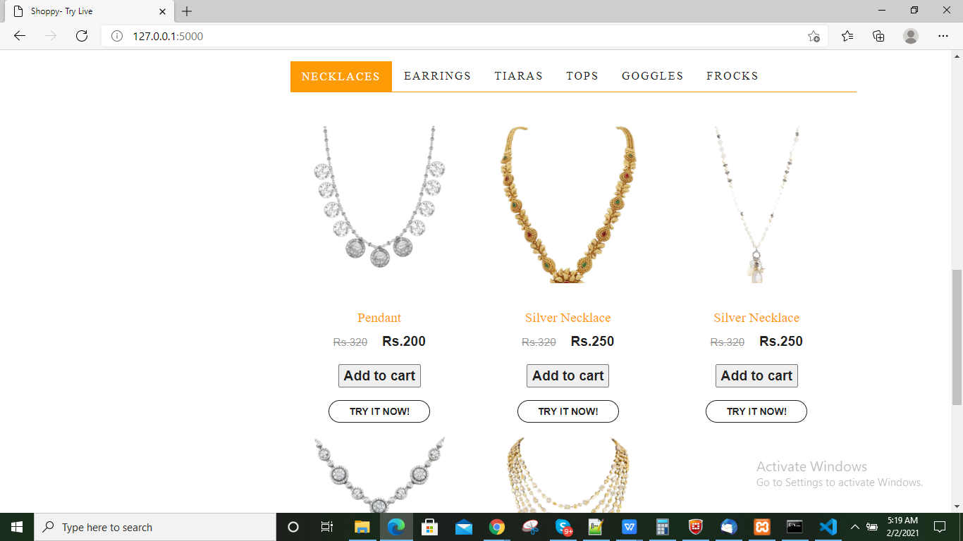

Figure 5.2: Browse Necklaces (User Interface)

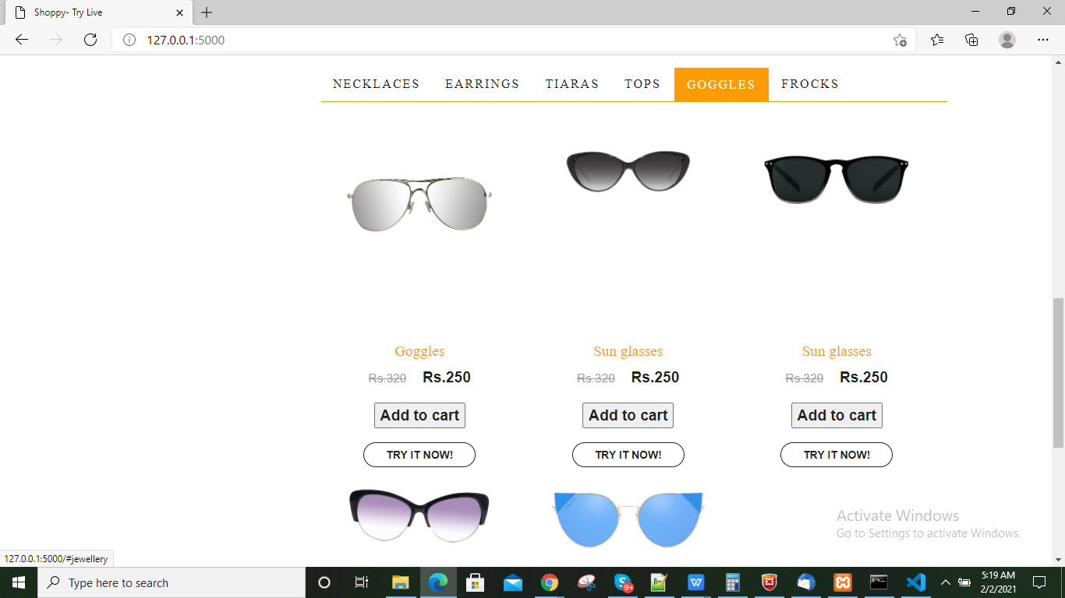

Figure 5.3: Browse Googles (User Interface)

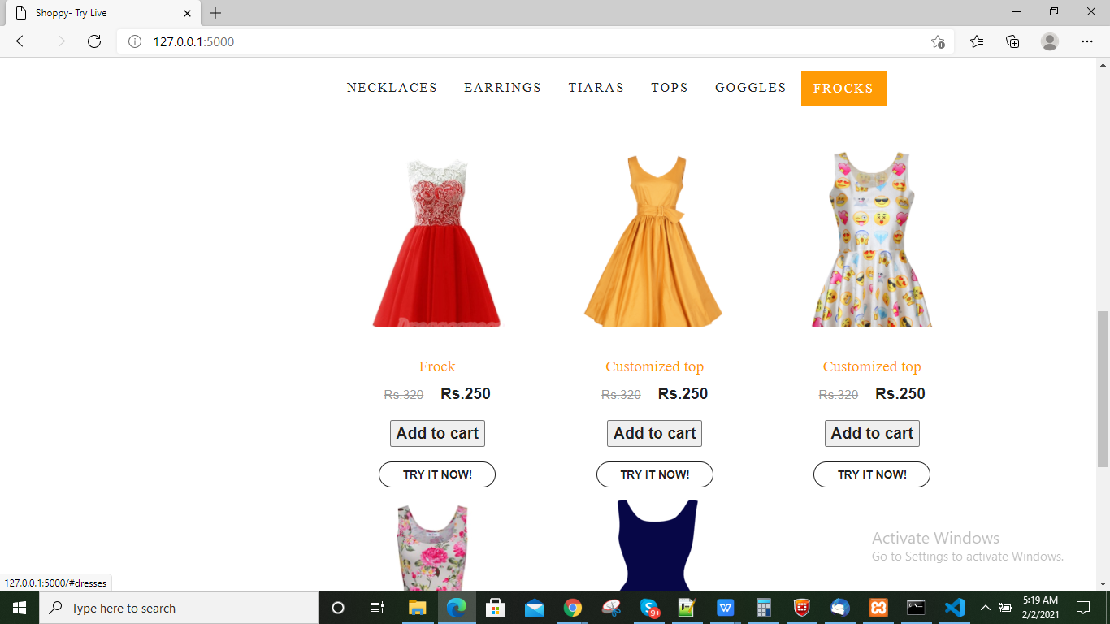

Figure 5.4: Browse Frocks (User Interface)

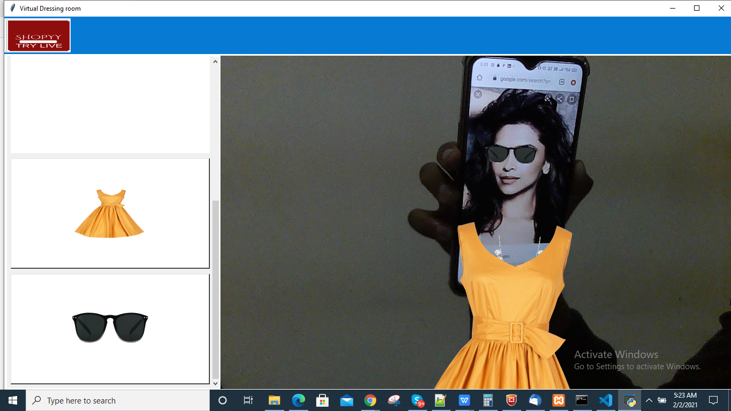

Figure 5.5: Output 1 (Detection and Masking)

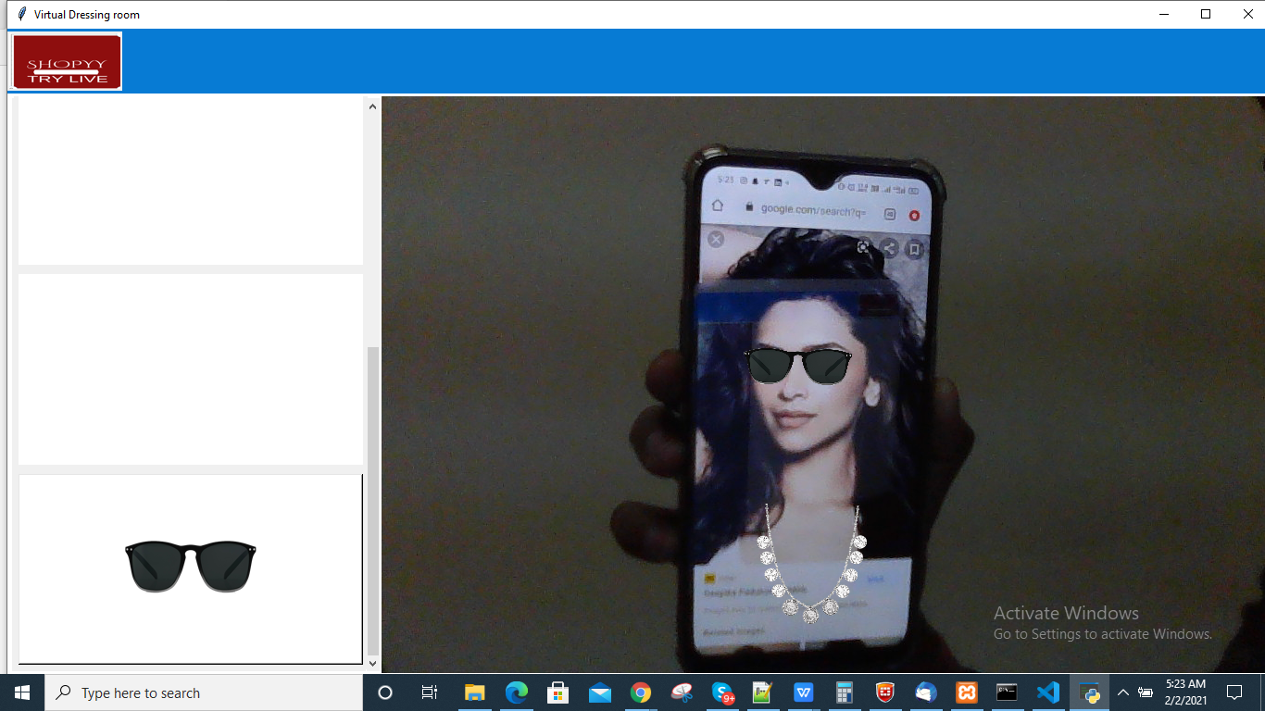

Figure 5.6: Output 2 (Detection and masking)

**6.TESTING**

* + - 1. **TESTING**
  1. **INTRODUCTION TO TESTING**

The purpose of testing is to discover errors. Testing is the process of trying to discover every conceivable fault or weakness in a work product. It provides a way to check the functionality of components, subassemblies, assemblies and/or a finished product. It is the process of exercising software with the intent of ensuring that the Software system meets its requirements and user expectations and does not fail in an unacceptable manner. There are various types of tests. Each test type addresses a specific testing requirement.

#### TYPES OF TESTING

**6.2.1 UNIT TESTING**

Unit testing involves the design of test cases that validate that the internal program logic is functioning properly, and that program inputs produce valid outputs. All decision branches and internal code flow should be validated. It is the testing of individual software units of the application .It is done after the completion of an individual unit before integration. This is a structural testing that relies on knowledge of its construction and is invasive. Unit tests perform basic tests at component level and test a specific business process, application, and/or system configuration. Unit tests ensure that each unique path of a business process performs accurately to the documented specifications and contains clearly defined inputs and expected results.

**6.2.2 INTEGRATION TESTING**

Integration tests are designed to test integrated software components to determine if they actually run as one program. Testing is event driven and is more concerned with the basic outcome of screens or fields. Integration tests demonstrate that although the components were individually satisfactory, as shown by successfully unit testing, the combination of components is correct and consistent. Integration testing is specifically aimed at exposing the problems that arise from the combination of components.

**6.2.3 FUNCTIONAL TESTING**

Functional tests provide systematic demonstrations that functions tested are available as specified by the business and technical requirements, system documentation, and user manuals

Functional testing is centered on the following items:

Valid Input : identified classes of valid input must be accepted.

Invalid Input : identified classes of invalid input must be rejected.

Functions : identified functions must be exercised.

Output : identified classes of application outputs must be

exercised.

Systems/Procedures : interfacing systems or procedures must be

invoked.

Organization and preparation of functional tests is focused on requirements, key functions, or special test cases. In addition, systematic coverage pertaining to identifying Business process flows; data fields, predefined processes.

**6.3 TEST CASES**

#### 6.3.1 Browse garments

|  |  |  |  |  |
| --- | --- | --- | --- | --- |
| Test case ID | Test case name | Purpose | Test Case | Output |
| 1 | Users browse the garments through GUI | To browse the content and view the desired products | The user browses the garments and view the garments | The garments are successfully displayed |

#### 6.3.2 Try Virtually

|  |  |  |  |  |
| --- | --- | --- | --- | --- |
| Test case ID | Test case name | Purpose | Input | Output |
| 1 | Try desired garments virtually | To try the desired garments virtually | User tries the desired garments virtually using the camera(User live feed) | The desired garments are virtually projected on user live feed |

* + - 1. **CONCLUSION**

**CONCLUSION & FUTURE SCOPE**

**7.1 PROJECT CONCLUSION**

A person travelling to shop and then buying clothes is a tedious task. In our work, User will be able to choose his favourite clothes according to his size without going outside. It will be a “user friendly” web-application so that he/she can try it virtually. An easy navigable, user-friendly Web app for the user to use. Overall, the presented virtual dressing room seems to be a good solution for quickly and accurately trying on clothes virtually.

### 7.2 FUTURE SCOPE

1. By using a Microsoft Kinect or azure Kinect, which can detect the image stream, depth stream. This can detect the body and face points more precisely and accurately.
2. We can create a smart mirror using this project, where the customers can get a real experience.
3. We can create a 3d model for the user based on the user complete picture and we can make the garments projected on their avatars.

**8.BIBLIOGRAPHY**

**8. BIBLIOGRAPHY**

### REFERENCES

[1]. Higgins, K. R., Ferraro, E. J., Tapley, J., Manickavelu, K., & Mukherjee, S. [2016]. U.S. Patent No. 9898742. Washington, DC: U.S. Patent and Trademark Office.

[2]. S. Malathi Professor, Department of Computer Science and Engineering, Panimalar Engineering College, Chennai, India [2018].

[3]. K. Seo and A. M. Fiore, “Effect of the fitting room environment on older clothing shoppers,” Journal of Retailing and Consumer Services, ELSEVIER, pp. 15- 22, 2018.

[4]. Eko Mulyanto Yuniarni; Mochammad Hariadi Department of Electrical Engineering, Institut Teknologi Sepuluh Nopember, Surabaya, Indonesia [2019].

[5]. Aladdin Masri, Muhannad Al-Jabi,-2020 Jordan International Joint Conference on Electrical and Information technology[JICEIT]-[2020]